1. Décrivez la journée de Frédéric Thibaut par écrit.

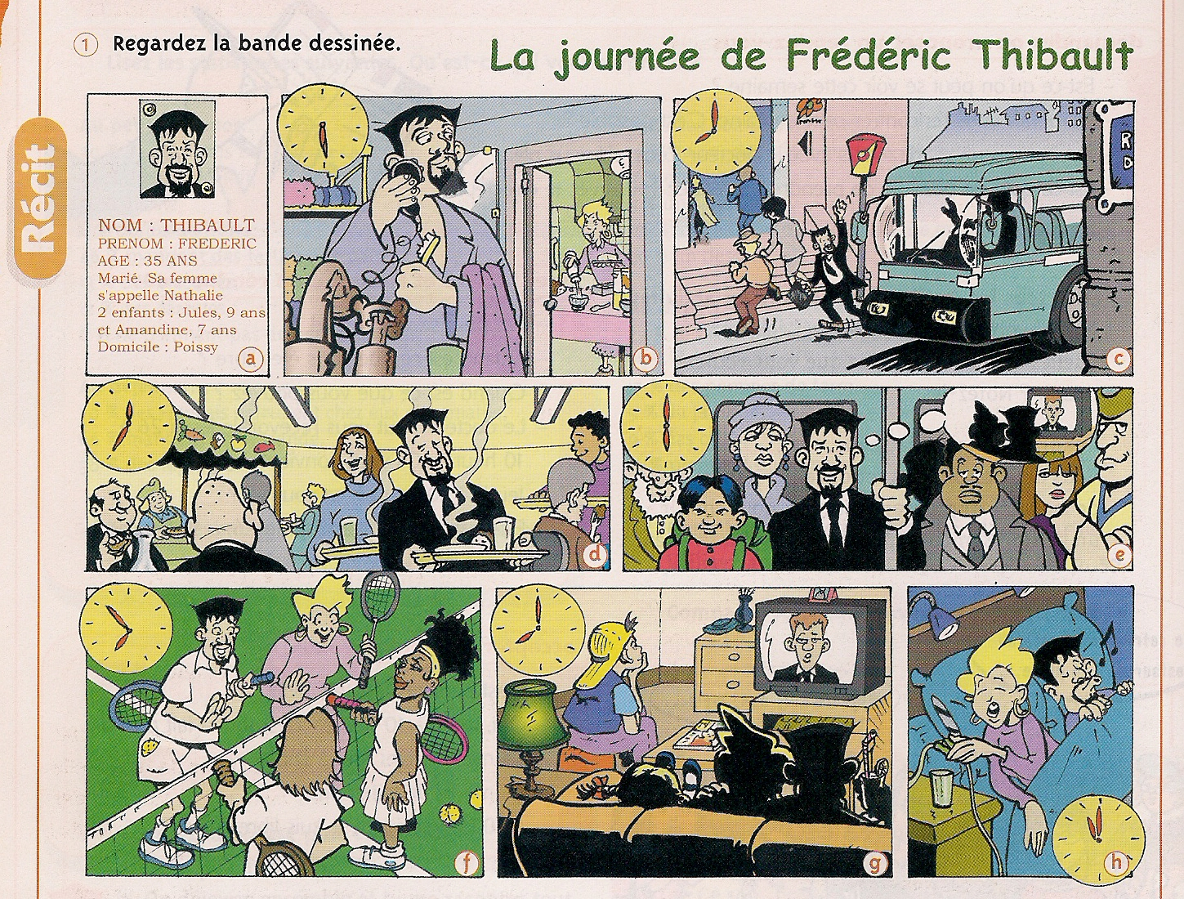

________________________________________________________________________________________________________________________________________________________________________________________________________________________________________________________________________________________________________________________________________________________________________________________________________________________________________________________________________________________________________________________________________________________________________________________________________________________________________________
____________________________________________________________________________________________________________________________________________________________
______________________________________________________________________________
____________________________________________________________________________________________________________________________________________________________
______________________________________________________________________________
____________________________________________________________________________________________________________________________________________________________
2. Vous êtes une célébrité : imaginez pourquoi vous êtes célèbre, ce que vous faites comme activités, etc. On vous demande un témoignage écrit à propos de votre quotidien pour un magazine du type « People ». Remplissez l’emploi du temps ci-dessous et ensuite racontez un peu ce que vous faites chaque jour, y compris le week-end.

 | lundi | mardi | mercredi | jeudi | vendredi | samedi | dimanche
Matin

Après-midi

Soir

________________________________________________________________________________________________________________________________________________________________________________________________________________________________________________________________________________________________________________________________________________________________________________________________________________________________________________________________________________________________________________________________________________________________________________________________________________________________________________
____________________________________________________________________________________________________________________________________________________________
______________________________________________________________________________
____________________________________________________________________________________________________________________________________________________________
______________________________________________________________________________
____________________________________________________________________________________________________________________________________________________________
________________________________________________________________________________________________________________________________________________________________________________________________________________________________________________________________________________________________________________________________________________________________________________________________________________________________________________________________________________________________________________________________________________________________________________________________________________________________________________

